STEP 1. Create an account
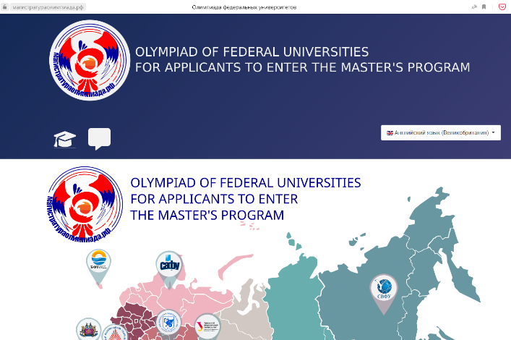
1. Go to Olympiad and select the language

2. Select the form of registration for foreign students and stateless persons
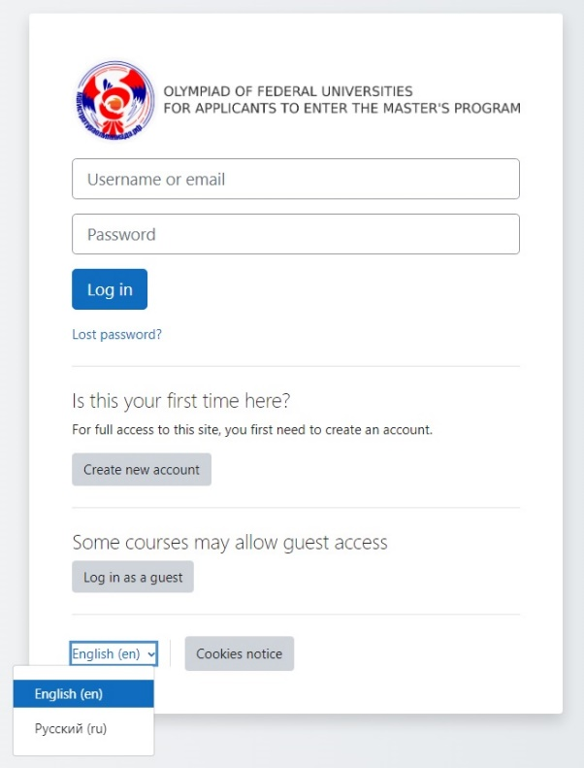
3. For full access to the Olympiad website, you must first create a participant account
for foreign students and stateless persons.
Pay attention to the following points:
! At registration it is necessary to specify the patronymic.
If you do not have it, then you need to put a sign «.»

! Enter the name of the University of your study (awarded Bachelor degree), enter the country of your study.
Enter the country of your study.
Enter the name of the University of your study (awarded Bachelor degree)
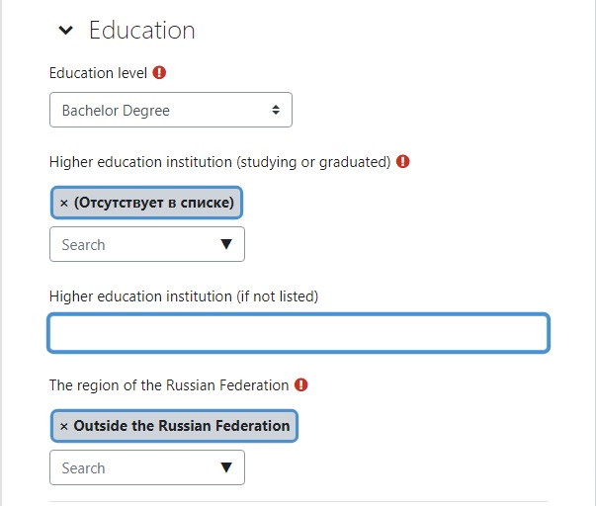

! Login and password from the student's personal account on the university website will not work, you must register a new account.
! Be sure to enter correct information about yourself, since after registration is completed, changes in registration information can only be made by submitting a request to the Olympiad support e-mail.
! Organizers do not guarantee the correct display of tasks from a phone or tablet. To pass the competition, use a computer or laptop.
Upon registration, an email will be sent to the email address you provided with simple instructions to complete your registration. If you have problems registering, please contact the site administrator.

STEP 2. Registration for the Olympiad

1. Log in to your account for foreign students and stateless persons.

2. To choose the direction of the Olympiad it is necessary to go to the category Отборочный этап/Qualifying stage

3. Select a course from the list. You can take part in an unlimited number of directions of the Olympiad.

But only 1 attempt is allocated for each test. One direction may not be repeated.

4. You can add new directions until February 17, 2023 (end of registration).

5. To enroll in a course, you must click on "Enroll me"

6. After registration, you can immediately start taking the test or go later before the end of the qualifying stage (until 23:59 Moscow time on February 17).
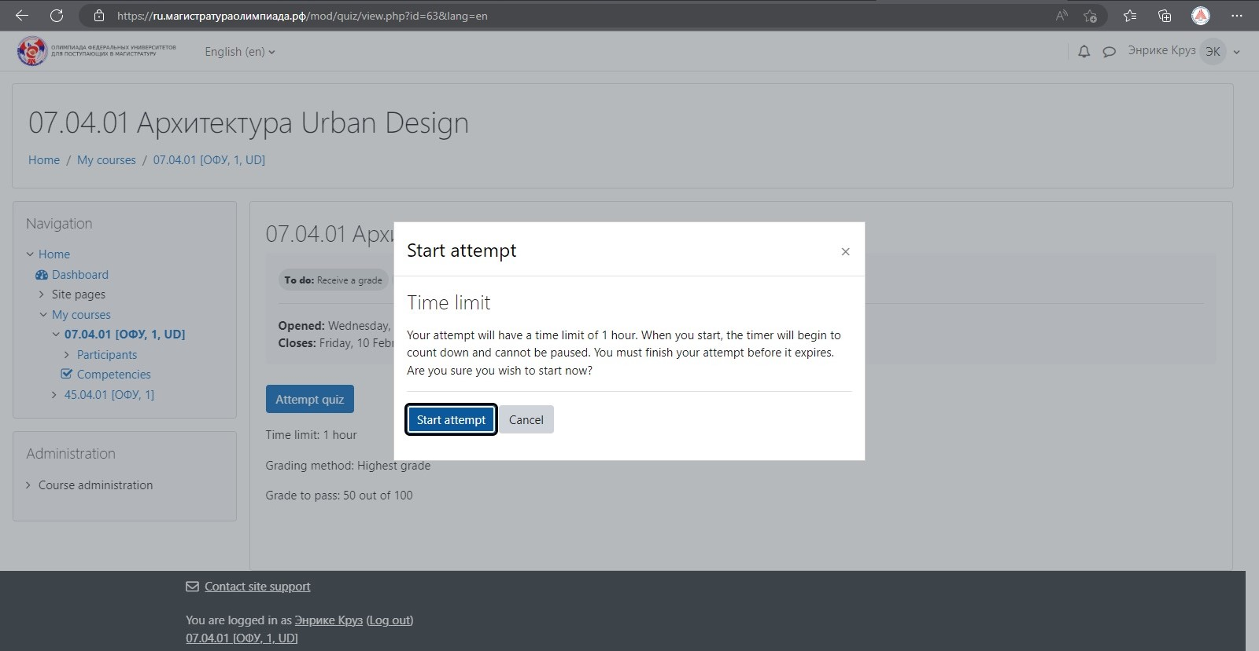

7. While passing the stage, watch the remaining time (1). The test run time is
1 hour. Do not worry and carefully go through the tasks. You can return to any of the completed questions (2).
Be sure to click on the “Finish attempt” button (3) at the end, as well as on “Submit all and complete the test” (4). Confirm sending again (5). After the allotted time (1 hour), your results will be sent automatically.
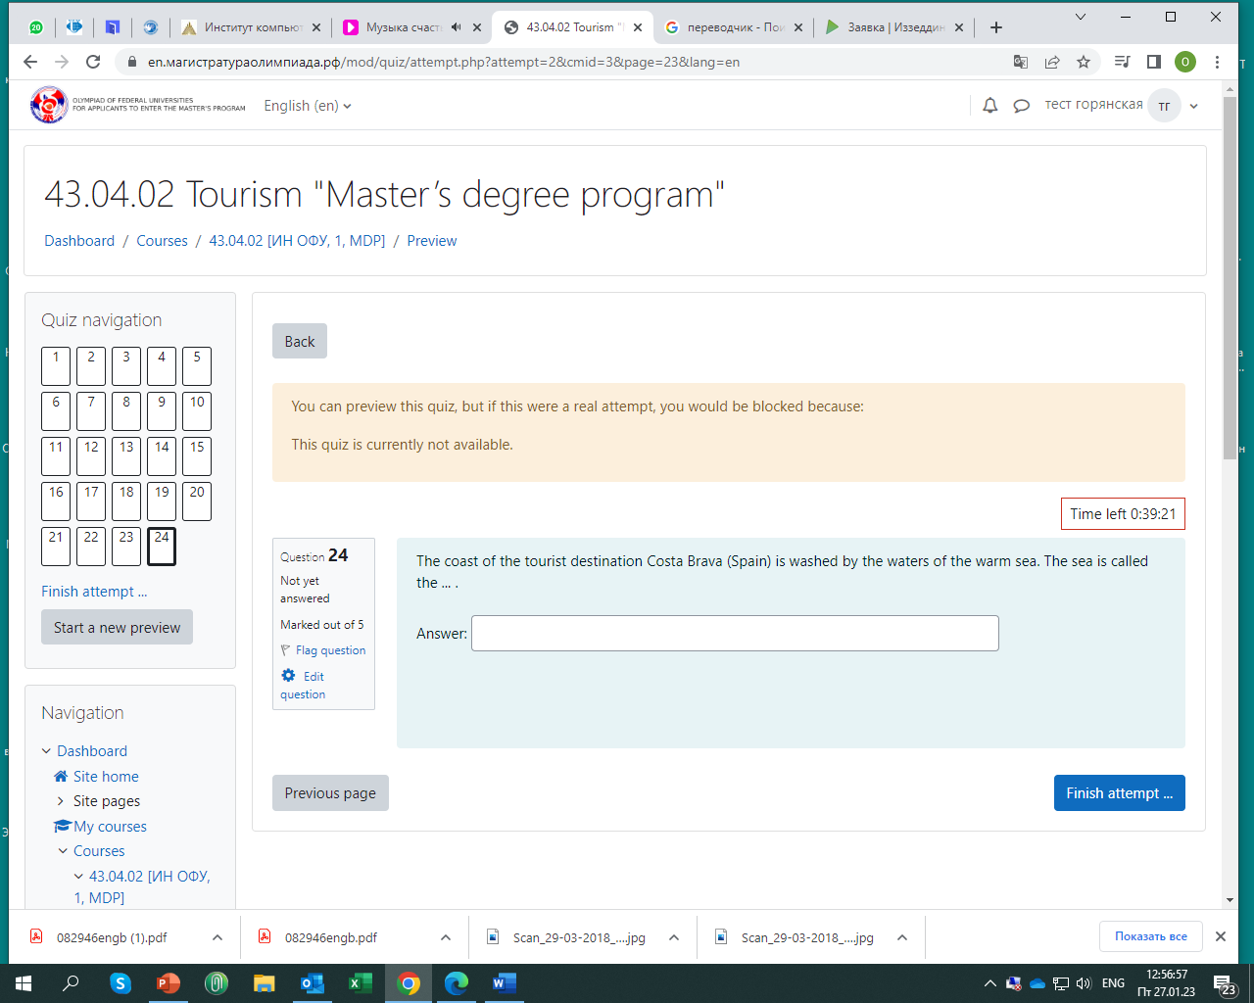

8. The list of directions you have signed up for can be seen in the section «My courses».

We wish you success in the first stage!
Organizational matters: +7 (863) 218-40-45
Technical questions: + +7 (863) 218-40-15
(We answer the phone on weekdays с 08:30 до 17:00)
E-mail: magolimprf@sfedu.ru

