OVERSEAS EXCHANGE
STUDENT MOBILITY PROGRAMME
APPLICATION PROCESS

2023-2024 Academic Year Application Period
07.11.2022-30.11.2022

- APPLICATION CRITERIA

- Students must complete at least one semester at the program they are enrolled in. During the application process, the students must have a cumulative CGPA which states their official student status at METU and the students must be able to continue their education at the same education level in the upcoming academic year, as well
- Undergraduate students must be at least in their 2nd year to be able to apply for the programme. Conditional Program ( Bilimsel Hazırlık) students and students studying in the Department of Basic English cannot apply for the programme since they do not have a cumulative CGPA.
- According to METU GPA assessment system, the students at Undergraduate level who have at least 2.50 or higher CGPA and the students at Graduate level who have at least 3.00 or higher CGPA can apply for the programme until the last day of application period. Some partner universities of ours may ask for higher CGPA criteria, which we cannot manage much. Therefore, please check the website of our International Cooperations Office and the home pages of the universities’ International Office about these specific situations.
- It is obligatory for Overseas Exchange students to have at least 30 ECTS (or around 5 courses) in their Exchange programme. Graduate students can also continue their Thesis Studies corresponding to this credit obligation, which is mandatory, too. Therefore, it is necessary for Exchange students to have at least 30 ECTS course load (which is the equivalent one that students need to take at METU) in their semester when they will have their Exchange programme. For Master’s and PhD. Students, since they still have a course load of Thesis Studies over 30 ECTS, there is no obstacle for them to participate in the programme. However, it is necessary for such Graduate students to find an available Thesis Advisor at the host university they will attend in Exchange programme and before leaving METU, it is necessary to have permission from the advisor at METU and the host university. The Erasmus + Departmental Coordinators will cancel out application of those students who do not have sufficient course load.
* In case that partner universities do not use ECTS, the evaluation is calculated dependent on course number. For such universities, it is expected that the students must successfully pass 3 courses out of 5.
- The students are strongly expected to register the courses they take at the host university to their departments at METU. This rule is available for all levels of education.
- The course grades FF / FD / W are not hinder for applications. However, the students with these grades must consider METU regulations and departmental policies, which may affect their participation in the programme. Furthermore, these FF / FD / W grades may influence the host university’s decision to accept these students.
- It is obligatory to have a valid English score to be able to complete the application. Detailed information about English language scores can be seen in the application call. https://ico.metu.edu.tr/duyuru/update-accepted-english-proficiency-exams-exchange-programs
8. The applications are made for the next academic year. For example, the applications received during 2022-23 Academic Year are for 2023-24 Academic Year (Fall and Spring semesters).

- IMPORTANT POINTS

- The students must make it sure that their departments also exist at the universities they make their applications. One university’s appearance on the online application system does not necessarily mean that this university offers the related or similar departments to Exchange students at all levels of education.
- The students can apply only for the level of education they are enrolled. Undergraduate students cannot make their application to attend Master’s or PhD programmes. Nevertheless, after the selection, if the department at METU and at Host University can approve it, it is possible to take courses at different levels.
- The host university may demand an official transcript of student to track the academic achievement of student before attending the programme and student success may play an important role in the acceptance process.
- During the online application process to the host university, the students may need to present an internationally recognized language certificate to the host University. It is not possible to attend Exchange programme at the host university if the students cannot meet the language requirements of the host university. Since the language requirements differ from university to university, the students should check the webpages of the host universities and ensure that they will provide these requirements until the end of online applications.
- The students who are placed to one university have to get ‘’ semester leave of absence’’ from METU before going to host university.
- Within the scope of Overseas Exchange Programme, the courses that are successfully passed at the host university must be registered at METU. The course placement procedure goes as below:
«.In correspondence with the course counters, at Undergraduate level, CC and higher grades I at Graduate level, BB and higher grades must be placed at student’s curriculum if they are regarded so. The students receive ‘’ EX’’ grade for these courses’ placement and are exempted from them. Also these courses are not included in CPGA. These courses appear as the semester in which the student participates in Erasmus programme on their transcripts. The corresponding course details of these courses at the Host university are indicated on the ‘’ Remarks’’ section.» In correspondence with the course counters, at Undergraduate level, CC and higher grades I at Graduate level, BB and higher grades must be placed at student’s curriculum if they are regarded so. The students receive ‘’ EX’’ grade for these courses’ placement and are exempted from them. Also these courses are not included in CPGA. These courses appear as the semester in which the student participates in Erasmus programme on their transcripts. The corresponding course details of these courses at the Host university are indicated on the ‘’ Remarks’’ section.

- HOW TO APPLY?

- The application are made ONLINE between November 7th and 30th, 2022. (You will have access to the link of online application page on ICO webpage.)
- At most 4 universities can be chosen. The list of partner universities can be found out on the ICO’s webpage.
- It is extremely important to consult with Erasmus Departmental Coordinators about the preferences during the application process. The departments may have various limitations of their own. You can have access to departmental limitations on the link below. http://ico.metu.edu.tr/departments-restrictions-outgoing-students-0. Moreover, you can have access to the link of Erasmus Departmental Coordinators below; http://ico.metu.edu.tr/departmental-coordinators.

- PLACEMENT PROCESS AND LANGUAGE PROFICIENCY

For each applicant, the placement calculation formula is calculated as below:

%50 İYS Puanı + %50 Dönem ağırlıklı CGPA
Semester-based CGPA: Each student’s CGPA is calculated according to the CGPAs of the applicants from the same department in the same grade and then a new application point is created.

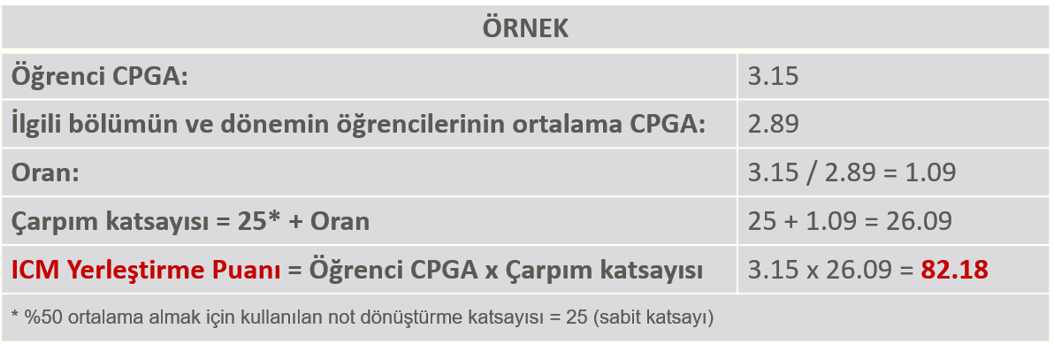

Beginning from the higher placement scores, the applicants are placed to one university they choose according to the university quotas.
To enable as many students at our university as possible to benefit from the Overseas Exchange Programme, the applicants can be placed to the universities only for 1 semester.
- 10 points will be decreased from the overall score of the students for each participation of the Overseas Exchange Programme in the same study cycle

- There will be a withdrawal period (to be announced later) for those students who decide to withdraw from the programme. 10 points will be decreased from overall score of the students if they withdraw from the program after the given deadline for withdrawal.

- 10 points will be added to the overall score of students with disabilities. The students are asked to upload the related medical rapport, approved by the doctor, on the online application system. Additional points will not be given if the rapports are not presented.

- 15 points will be added to the overall score of the students who are the relatives of martyrs and veterans. The proving documents must be uploaded to the online application platform before the application deadline. Additional points will not be given if the official documents are not presented.

- 10 points will be added to the overall score of the students who have been under protection by 2828 Social Services Law. The proving documents must be uploaded to the online application platform before the application deadline. Additional points will not be given if the official documents are not presented.

- GRANT & EXPENSES

- Overseas Exchange students are exempt from the tuition fees at the university they are placed. (Apart from a few exceptional universities). However, the students who need to pay tuition fees to METU will still need to pay their fees to METU; they are still exempt from paying fees to the Host University.
- Overseas Exchange Program is a non-granted (without scholarship) program. Students are responsible for all living, accommodation and personal expenses while at the host institution.

