I am Maria Ciavarella of the International Relations Office at the University of Foggia; with this email I would like to invite you in Vieste, Province of Foggia, where the third edition of our Erasmus Staff Week will take place between 19 and 24 June 2017.

It will be a relevant occasion to exchange ideas and best practice.

Attached you may find some useful information on how to join us!

During the past two editions, we hosted more than 100 colleagues from all over Europe.

Deadline for applying: 31st March, 2017

Participation Fees: 150 euro

The application form must be filled in online at:

https://goo.gl/forms/jyfPDRnWdwI49vMz1

More information and some photos of the past editions are available on:

http://staffmobility.eu/staffweek/international-week-4

PARTICIPANTS FACEBOOK GROUP
https://www.facebook.com/groups/internationalweekunifg3/

For any further information you may need, please feel free to send me emails,

Thank you very much indeed and kind regards,

Maria Ciavarella
Settore Relazioni Internazionali
UNIFG

FROM BARI AIRPORT

4 BUS TRAVELS FROM BARI AIRPORT TO VIESTE (PIAZZA ALDO MORO)

Tickets may be purchased online or on board Ticket price: € 20,00
TIMETABLE

Outbound

Line code: 03R Bus travel code: 316R Line: BARI-GARGANO EASY TO REACH

DEPARTURE from BARI (AEROPORTO)
TIME 09:30:00
- ARRIVAL to VIESTE (P.le A. Moro)
TIME 12:21:00

Line code: 03R Bus travel code: 317R Line: BARI-GARGANO EASY TO REACH

DEPARTURE from BARI (AEROPORTO)
TIME 12:00:00
- ARRIVAL to VIESTE (P.le A. Moro)
TIME 14:51:00

Line code: 03R Bus travel code: 318R Line: BARI-GARGANO EASY TO REACH

DEPARTURE from BARI (AEROPORTO)
TIME 17:15:00
- ARRIVAL to VIESTE (P.le A. Moro)
TIME 20:06:00

Line code: 03R Bus travel code: 319R Line: BARI-GARGANO EASY TO REACH

DEPARTURE from BARI (AEROPORTO)
TIME 23:00:00
- ARRIVAL to VIESTE (P.le A. Moro)
TIME 01:51:00

For reservation :

http://www.aeroportidipuglia.it/bus-pugliairbus-/-/cotrap/render

The bus stop is located just outside the Airport Arrivals after passing the Taxi stand.

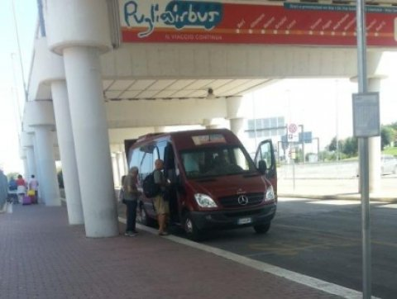

From Piazza Aldo Moro (Vieste) to I MELOGRANI

650 m – 8 min walking
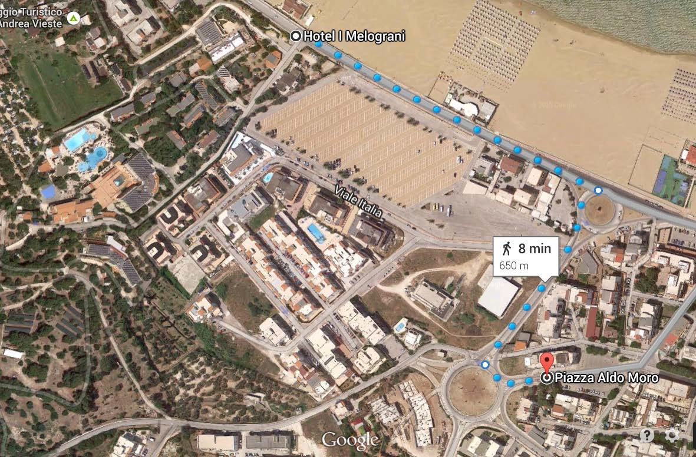

FROM VIESTE TO BARI AIRPORT

4 bus travels from VIESTE to BARI

Outbound

Line code: 03 Bus travel code: 316 Line: GARGANO-BARI EASY TO REACH

DEPARTURE from VIESTE (P.le A. Moro)
TIME 02:22:00
1 ARRIVAL to BARI (AEROPORTO)
TIME 05:15:00

Line code: 03 Bus travel code: 317 Line: GARGANO-BARI EASY TO REACH

DEPARTURE from VIESTE (P.le A. Moro)
2 TIME 07:52:00
ARRIVAL to BARI (AEROPORTO)

TIME 10:45:00

Line code: 03 Bus travel code: 318 Line: GARGANO-BARI EASY TO REACH

DEPARTURE from VIESTE (P.le A. Moro)
TIME 13:37:00
- ARRIVAL to BARI (AEROPORTO)
TIME 16:30:00

Line code: 03 Bus travel code: 319 Line: GARGANO-BARI EASY TO REACH

DEPARTURE from VIESTE (P.le A. Moro)
TIME 16:52:00
- ARRIVAL to BARI (AEROPORTO)
TIME 19:45:00

FROM NAPOLI – CAPODICHINO AIRPORT

Once outside the Airport take the shuttle bus “ALIBUS” to Central Train station – Piazza Garibaldi (ticket: 4 euro inside).

Timetable

https://www.anm.it/Upload/RES/PDF/ORARI/Capodichino%202014%20GIUGNO.pdf

From Napoli Bus Station take the “CLP” bus to Foggia (ticket: 11 euro)

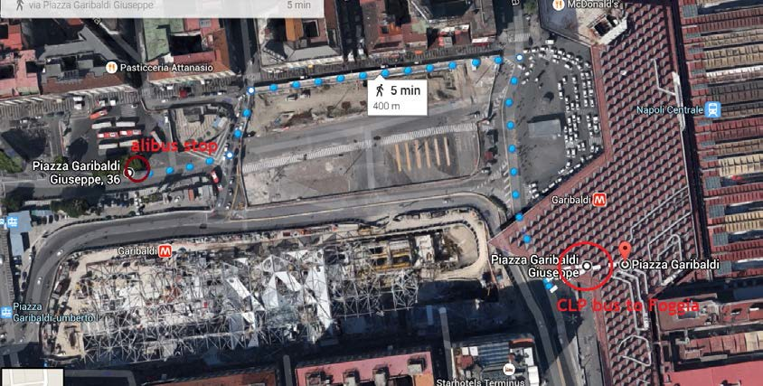

CLP BUS STOP TO FOGGIA

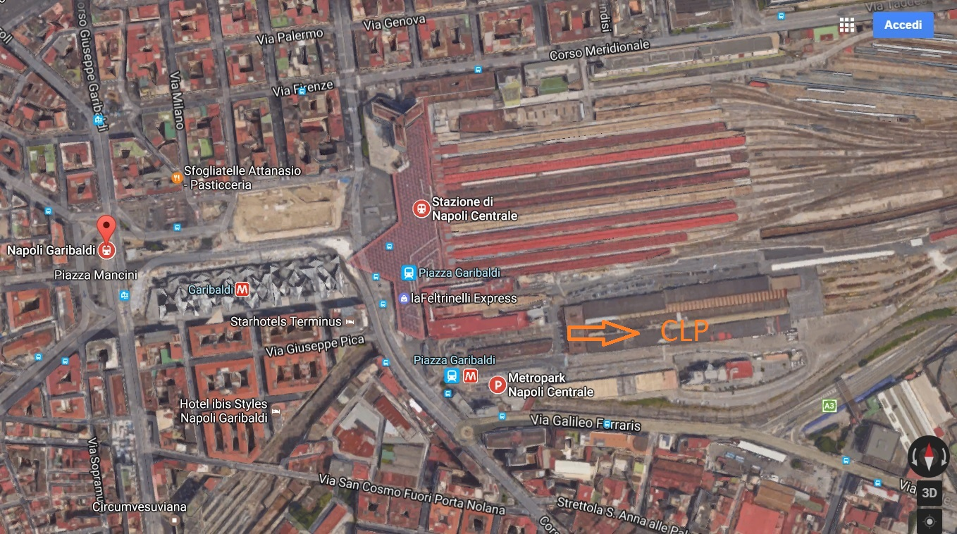

BUS CLP TIMETABLE (NAPOLI – FOGGIA - NAPOLI) MONDAY - SATURDAY

http://www.clpbus.it/web/main.php#2

Once you get in Foggia you can reach VIESTE by bus.

BUS TIMETABLE FOGGIA (central station) – VIESTE (piazza Aldo Moro) –
FOGGIA (central station)

http://goo.gl/2rh0cD

You can buy the ticket at “BAR KIWI” in front of Foggia Central Station

http://goo.gl/uJYAxf

Once in VIESTE (piazza Aldo Moro) follow the indication at page 2.

FROM ROME AIRPORT (CIAMPINO –
FIUMICINO DA VINCI)

  - TAKE THE SHUTTLE BUS TO ROMA TERMINI (CENTRAL STATION)

Diﬀerent companies at Airport bus stop - Ticket: 4/5 euro

  - FROM ROMA TERMINI TO FOGGIA BY TRAIN
http://www.trenitalia.com/cms/v/index.jsp?vgnextoid=4ddd 1a035296f310VgnVCM1000005817f90aRCRD

Departure  08:05Roma Termini | Arrival  10:56Foggia
Departure  08:14Roma Termini | Arrival  12:50Foggia
Departure  14:50Roma Termini | Arrival  17:41Foggia
Departure  18:00Roma Termini | Arrival  20:56Foggia

  - From Foggia to Vieste follow the indication at page 4.

FROM ROME TO VIESTE BY BUS
BUS TIMETABLE ROME - VIESTE - ROME
From Rome (Tiburtina station) 17:00 PM (departure) to Vieste (p.zza Aldo Moro) 23.50 PM
(arrival)
From Vieste (p.zza Aldo Moro) 3.30 am (departure) - Rome (Tiburtina station) 10.20 am
(arrival).

RESERVATION
http://www.ferroviedelgargano.com/en/ then click on NATIONAL BUS
and query Rome - Vieste or Vieste - Rome for reservation.

FROM BARI AIRPORT

4 BUS TRAVELS FROM BARI AIRPORT TO VIESTE (PIAZZA ALDO MORO)

Tickets may be purchased online or on board Ticket price: € 20,00
TIMETABLE

Outbound

Line code: 03R Bus travel code: 316R Line: BARI-GARGANO EASY TO REACH

DEPARTURE from BARI (AEROPORTO)
TIME 09:30:00
- ARRIVAL to VIESTE (P.le A. Moro)
TIME 12:21:00

Line code: 03R Bus travel code: 317R Line: BARI-GARGANO EASY TO REACH

DEPARTURE from BARI (AEROPORTO)
TIME 12:00:00
- ARRIVAL to VIESTE (P.le A. Moro)
TIME 14:51:00

Line code: 03R Bus travel code: 318R Line: BARI-GARGANO EASY TO REACH

DEPARTURE from BARI (AEROPORTO)
TIME 17:15:00
- ARRIVAL to VIESTE (P.le A. Moro)
TIME 20:06:00

Line code: 03R Bus travel code: 319R Line: BARI-GARGANO EASY TO REACH

DEPARTURE from BARI (AEROPORTO)
TIME 23:00:00
- ARRIVAL to VIESTE (P.le A. Moro)
TIME 01:51:00

For reservation :

http://www.aeroportidipuglia.it/bus-pugliairbus-/-/cotrap/render

The bus stop is located just outside the Airport Arrivals after passing the Taxi stand.

From Piazza Aldo Moro (Vieste) to I MELOGRANI

650 m – 8 min walking

FROM VIESTE TO BARI AIRPORT

4 bus travels from VIESTE to BARI

Outbound

Line code: 03 Bus travel code: 316 Line: GARGANO-BARI EASY TO REACH

DEPARTURE from VIESTE (P.le A. Moro)
TIME 02:22:00
1 ARRIVAL to BARI (AEROPORTO)
TIME 05:15:00

Line code: 03 Bus travel code: 317 Line: GARGANO-BARI EASY TO REACH

DEPARTURE from VIESTE (P.le A. Moro)
2 TIME 07:52:00
ARRIVAL to BARI (AEROPORTO)

TIME 10:45:00

Line code: 03 Bus travel code: 318 Line: GARGANO-BARI EASY TO REACH

DEPARTURE from VIESTE (P.le A. Moro)
TIME 13:37:00
- ARRIVAL to BARI (AEROPORTO)
TIME 16:30:00

Line code: 03 Bus travel code: 319 Line: GARGANO-BARI EASY TO REACH

DEPARTURE from VIESTE (P.le A. Moro)
TIME 16:52:00
- ARRIVAL to BARI (AEROPORTO)
TIME 19:45:00

FROM NAPOLI – CAPODICHINO AIRPORT

Once outside the Airport take the shuttle bus “ALIBUS” to Central Train station – Piazza Garibaldi (ticket: 4 euro inside).

Timetable

https://www.anm.it/Upload/RES/PDF/ORARI/Capodichino%202014%20GIUGNO.pdf

From Napoli Bus Station take the “CLP” bus to Foggia (ticket: 11 euro)

CLP BUS STOP TO FOGGIA

BUS CLP TIMETABLE (NAPOLI – FOGGIA - NAPOLI) MONDAY - SATURDAY

http://www.clpbus.it/web/main.php#2

Once you get in Foggia you can reach VIESTE by bus.

BUS TIMETABLE FOGGIA (central station) – VIESTE (piazza Aldo Moro) –
FOGGIA (central station)

http://goo.gl/2rh0cD

You can buy the ticket at “BAR KIWI” in front of Foggia Central Station

http://goo.gl/uJYAxf

Once in VIESTE (piazza Aldo Moro) follow the indication at page 2.

FROM ROME AIRPORT (CIAMPINO –
FIUMICINO DA VINCI)

  - TAKE THE SHUTTLE BUS TO ROMA TERMINI (CENTRAL STATION)

Diﬀerent companies at Airport bus stop - Ticket: 4/5 euro

  - FROM ROMA TERMINI TO FOGGIA BY TRAIN
http://www.trenitalia.com/cms/v/index.jsp?vgnextoid=4ddd 1a035296f310VgnVCM1000005817f90aRCRD

Departure  08:05Roma Termini | Arrival  10:56Foggia
Departure  08:14Roma Termini | Arrival  12:50Foggia
Departure  14:50Roma Termini | Arrival  17:41Foggia
Departure  18:00Roma Termini | Arrival  20:56Foggia

  - From Foggia to Vieste follow the indication at page 4.

FROM ROME TO VIESTE BY BUS
BUS TIMETABLE ROME - VIESTE - ROME
From Rome (Tiburtina station) 17:00 PM (departure) to Vieste (p.zza Aldo Moro) 23.50 PM
(arrival)
From Vieste (p.zza Aldo Moro) 3.30 am (departure) - Rome (Tiburtina station) 10.20 am
(arrival).

RESERVATION
http://www.ferroviedelgargano.com/en/ then click on NATIONAL BUS
and query Rome - Vieste or Vieste - Rome for reservation.

