Dear colleague,
Warm greetings from Universum College, Prishtina, Kosovo!

We are excited to announce and invite your staff to participate at 4th International Staff Week, being placed on the dates of 08-12 of May 2023.
The staff are encouraged to participate under the framework of Erasmus+ Staff Mobility of Training.

The topic of the training will be:
"Promoting global sustainability through climate change, resource management, renewable energy, global governance, sustainable cities, and global justice" .
In addition to the training program there will be organized cultural/networking activities and the Study Abroad Fair!

Please find attached a brochure with more information regarding the staff week and application procedure.

APPLICATION FORM
Deadline for application will be the 24th of April.

We kindly ask you to share the call to your staff and colleagues. In case this email is not sent to the right person for the dissemination of the call, we apologize and kindly ask to forward the email to the relevant office/person.

We are looking forward to welcoming you to Kosovo!

All the best,
The international Office
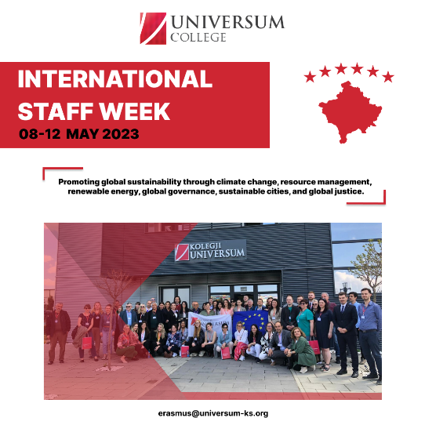

--
Erasmus + Projects Office

Universum College Pristina, Kosovo
044 144 062 www.universum-ks.org
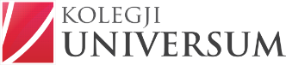
The most international University in the Balkans ∣ Exchanges and International Degrees

