INFORMATION SHEET-UPM
Departmental Coordinators

Schools - UPM | Coordinators
ETS de Arquitectura  Avda. Juan Herrera, 4.  Ciudad Universitaria  28040-Madrid-ESPAÑA  Code : 581/0731 (Architecture and Town Planning) www.aq.upm.es | Prof. Javier García-Germán  Tel: +34 91 336 5249  Fax: +34 91 336 6521  Email: intercambio.arquitectura@upm.es
ETS de Ingeniería Aeronáutica y del Espacio  Pza. Cardenal Cisneros, s/n  Ciudad Universitaria.  28040-Madrid-ESPAÑA  Code : 525/0716 (Aerospace)  www.etsiae.upm.es | Prof. Cristina Cuerno  Tel: +34 91 336 6356  Fax: +34 91 336 6356  Email: subdirector.re.aeronauticos@upm.es
ETS de Ingeniería Agronómica, Alimentaria y de Biosistemas  Avda. Complutense s/n,  Ciudad Universitaria.  28040-Madrid-ESPAÑA  Code : 62/081 (Agriculture, Biotechnology)  Code : 0712 (Environmental Protection Technology)  Código de Área : 0721 (Food Processing)  www.etsiabb.upm.es | Prof. Maria Jesús Villamide  Tel: +34 91 336 5807  Fax: +34 91 543 4879  Email: subdirector.pei.etsiabb@upm.es
ETSI Caminos, Canales y Puertos  c/ Prof. Aranguren, s/n  28040 Madrid- ESPAÑA  Code : 582/0732 (Civil Engineering and Construction)  Code : 543/ 0722 (Materials Science) www.caminos.upm.es | Prof. Manuel Romana  Tel: +34 91 336 6734  Fax: +34 91 549 2289  Email: subdirector.ri.caminos@upm.es
ETSI Industriales  c/ José Gutiérrez Abascal, 2  28006 Madrid- ESPAÑA  Code : 52/ 071 (Engineering, Technology) www.etsii.upm.es | Prof. Juan de Juanes Márquez  Tel: +34 91 336 3047  Fax: +34 91 336 3279  Email: internacional.industriales@etsii.upm.es
ETSI Minas  c/ Ríos Rosas, 21  28003 Madrid-ESPAÑA  Code :52/ 071 (Engineering, Technology)  Code : 443/0532 (Earth Science)  Code: 544/0724 (Mining and Extraction) www.minasyenergia.upm.es | Prof. Liliana Medic  Tel: +34 91 336 3241  Fax: +34 91 336 7068  Email: liliana.medic@upm.es

ETS de Ingeniería de Montes, Forestal y del Medio Natural  Ciudad Universitaria  28040-Madrid-ESPAÑA  Code : 623/0821 (Forestry)  Code : 422/0521 (Environmental Science)  www.montesymedionatural.upm.es | Prof. Mª Paz Arraiza  Tel: +34 91 336 7097  Fax: +34 91 336 7093  Email: subdirector.eu.montes@upm.es  Prof. Leticia de Salas  Tel: +34 91 336 5204  Fax: +34 91 336 7554  Email: subdirector.eure.forestales@upm.es
ETSI Navales  Avda. del Arco de la Victoria s/n  28040-Madrid-Spain  Code : 52/ 071 (Ingeniería, Tecnología) www.etsin.upm.es | Prof. Miguel Angel Herreros  Tel: +34 91 336 7134  Fax: +34 91 544 2149  Email: miguelangel.herreros@upm.es
ETSI Telecomunicación  Ciudad Universitaria  28040-Madrid-ESPAÑA  Code : 523/0714 (Electronics and Automation)  Code : 725/0914 (Medical Diagnostic and Treatment Technology)  Code : 481/061 (Computer Science)  www.etsit.upm.es | Prof. Luis Salgado  Tel: +34 91 336 7299  Fax: +34 91 336 7299  Email: internacional@etsit.upm.es
ETSI en Topografía, Geodesia y Cartografía  Complejo Politécnico de Vallecas  km. 7 de la Carretera de Valencia  28031-Madrid-ESPAÑA  Code : 443/ 0521 (Earth Science, Geodesy) www.topografia.upm.es | Prof. José Juan Arranz  Tel: +34 91 336 6477  Fax: +34 91 332 2560  Email: subdirector.internacional.topografia@upm.es
ETSI Informáticos  Campus de Montegancedo, s/n.  Boadilla del Monte  28660-Madrid-ESPAÑA  Code : 481/ 0611 (Computer Science) www.etsiinf.upm.es | Prof. Marinela García  Tel: +34 91 336 6608  Fax: +34 91 336 3667  Email: international-office@fi.upm.es
ETS de Edificación  Avda Juan de Herrera, 6  Ciudad Universitaria  28040-Madrid-ESPAÑA  Code : 581/ 0731 (Architecture and Construction) www.edificacion.upm.es | Prof. Pilar Izquierdo  Tel: +34 91 336 7638  Fax: +34 91 336 7634  Email: oficinademovilidad.edificacion@upm.es
ETS de Ingeniería de Sistemas Informáticos  Complejo Politécnico de Vallecas  km. 7 de la Carretera de Valencia  28031-Madrid-ESPAÑA  Code : 48/ 061 (Informatics)  www.etsisi.upm.es | Prof. Pilar Manzano  Tel: +34 91 336 7902  Fax: +34 91 336 5483  Email: international.relations@eui.upm.es
ETS de Ingeniería y Diseño Industrial  c/ Ronda de Valencia, 3  28012 Madrid-Spain  Code : 52/071 (Industrial Engineering) www.etsidi.upm.es | Prof. Isabel Carrillo  Tel: +34 91 336 7688  Fax: +34 91 336 5588  Email: subdirector.ari.industrial@upm.es

ETS de Ingeniería Civil  c/Alfonso XII, 3  28014 Madrid-ESPAÑA  Code : 582/0732 (Civil Engineering) www.ingenieriacivil.upm.es | Prof. Sara García  Tel: +34 91 336 7755  Fax: +34 91 336 7961  Email: sara.garcia@upm.es
ETS de Ingeniería y Sistemas de Telecomunicación  Complejo Politécnico de Vallecas  km. 7 de la Carretera de Valencia  28031-Madrid-ESPAÑA  Code : 523/0714 (Electronic Engineering)  Code : 213/0211 (Audio-visual Tecnique and Media Production)  Code : 48/061 (Telematics Enginnering) www.etsist.upm.es | Prof. Rafael Herredón  Tel: +34 91 336 7774  Fax: +34 91 331 9229  Email: movilidad@etsist.upm.es
Centro Superior de Diseño y Moda  Campus Sur  Ctra. Valencia, km.7  28031 Madrid-ESPAÑA  Code : 214/0212 (Design Fashion)  www.csdmm.upm.es | Prof. Guillermo García  Tel: +34 91 331 0126  Fax: +34 91 332 1767  Email: gacademica.csdmm@upm.es
Facultad de Ciencias de la Actividad Física y el Deporte (INEF)  c/Martín Fierro, s/n  Ciudad Universitaria  28040-Madrid-ESPAÑA  Code : 813/1014 (Sport)  www.inef.upm.es | Prof. Pedro José Benito  Tel: +34 91 336 4012  Fax: +34 91 336 4069  Email: vicedecano.cae.inef@upm.es

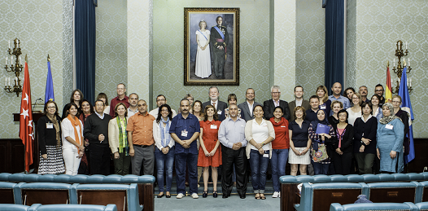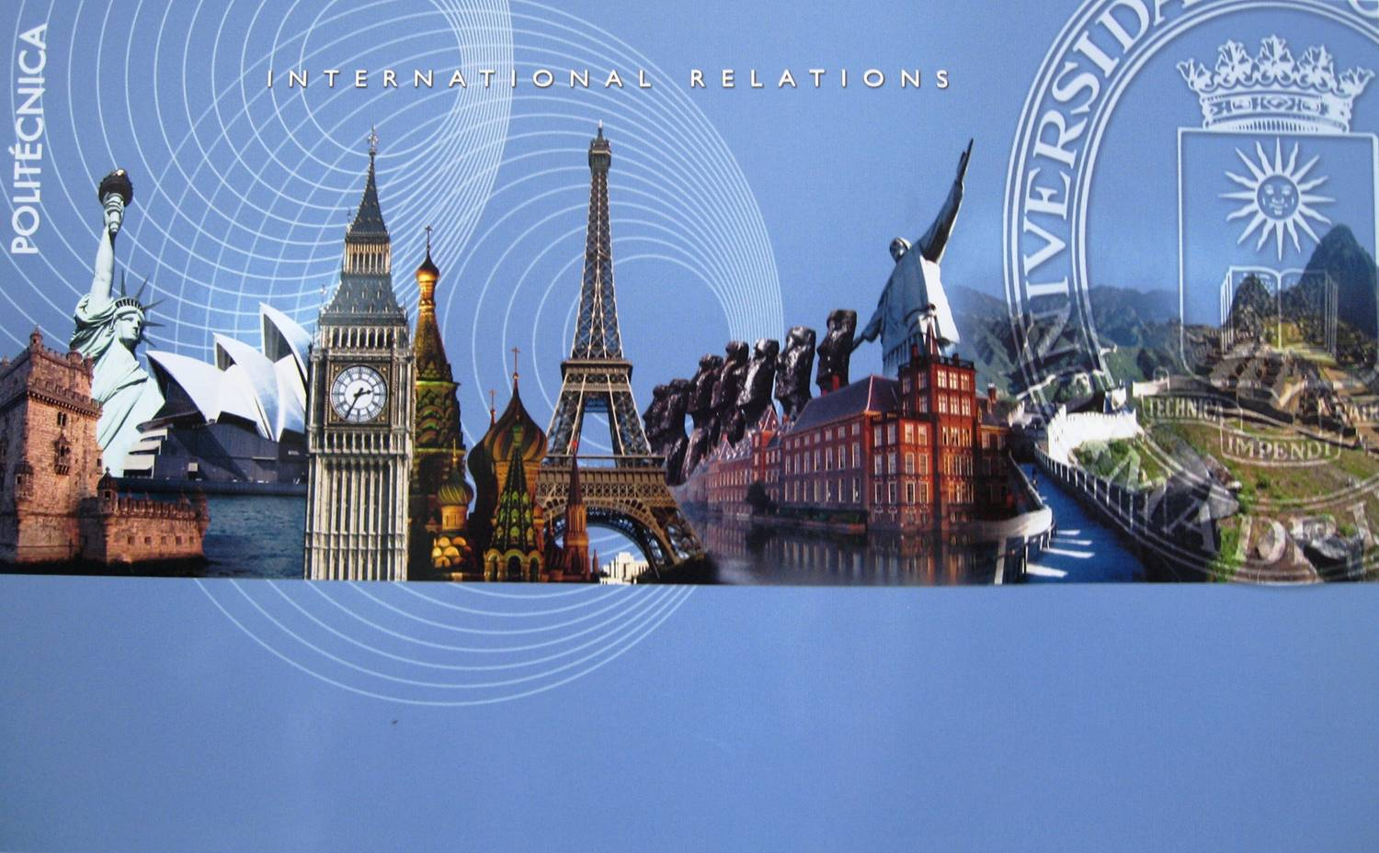

ERASMUS STAFF WEEK
at
UNIVERSIDAD POLITÉCNICA DE MADRID
12 to 16 June, 2017

The Universidad Politécnica de Madrid (UPM) is pleased to announce its Staff Week which will be held from 12 to 16 June in Madrid, and welcomes teaching and non- teaching staff members, under the Erasmus+ framework.
Participants can experience Spanish culture and language with other colleagues and representatives of partners.

The working language will be in English.

Fill in the Registration Form and send it back to victoria.guijo@upm.es by 31.03.2017.

We are certain that this proposal will increase our international experience and be beneficial for all the participating Universities, so please, forward this invitation to those people who might be interested in joining us for this event.

PRELIMINARY PROGRAM

June, 12
LOCATION: Rectorate-Building "A"- c/ Ramiro de Maeztu, 7. 28040 Madrid. Spain. Meeting point: 0 Floor - Time 9:00 h.
Opening session | Welcoming to UPM - Presentation
10:00 - 10:30 | European Programs : Athens, Erasmus+, KA1, KA2
11:00 - 11:30 | Language Program
11:30 - 12:00 | Cooperation & Development
12:00 - 12:30 | Asia and Erasmus+ Associated Partners
15:00 - 16:30 | Spanish Language Course

June, 13
LOCATION: Rectorate-Building "A"- c/ Ramiro de Maeztu, 7. 28040 Madrid. Spain. Meeting point: 0 Floor - Time 8:30 h.
09:00 - 12:00 | Partners Universities: “Short Presentations” (10 min/each)
12:00 - 13:00 | Talk: “Thinking: A Cultural Perspective”

June, 14
09:00 - 14:00 | Meeting of Erasmus+ Coordinators of UPM Department

June, 15
LOCATION: ETSI Telecomunicación.
Meeting point: Hall of the Building A
09:00 - 13:30  15:00 - 18:30 | - 30th Anniversary of Erasmus  - Sessions, Workshops at ETSI Telecomunicación  UPM City Tour

June, 16
LOCATION: Rectorate-Building "A". c/ Ramiro de Maeztu, 7. 28040 Madrid. Spain Meeting point: 0 Floor - Time 09:00 h
Closing session | Farewell from UPM  Feedback - Closing sessions  Attendance Certificates will be given to all participants

Registration Form
Name of your Institution
Erasmus Code
Title Ms/Mr
First name
Last name
Position
City and Country
Email
Departmental areas interesting for you and having a meeting with the coordinator. (See the Advisors of UPM Departments)
-
-
-
-
-
-
-
Would you like to give a short presentation about your home University : Yes No
For the Spanish level course : Advanced Intermediate Beginners None
Form to be sent to the International Mobility Office by Email: victoria.guijo@upm.es

