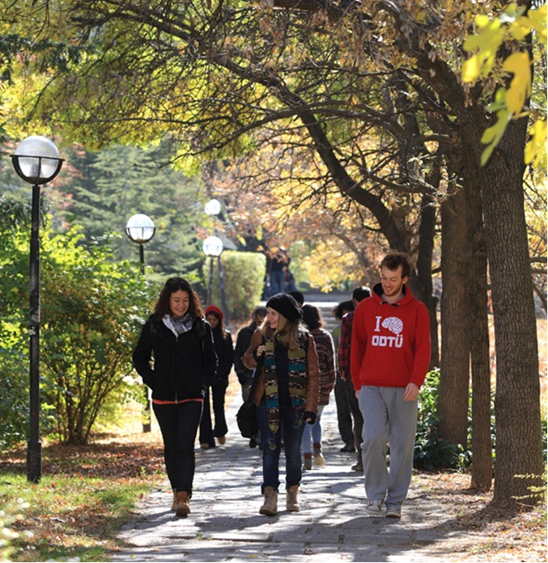

Orientation Booklet for Incoming Staff

2017-2018 Spring

Content:

CONTACT DETAILS OF ADVISORS 2

Emergency Contact Numbers 2

ABOUT TURKEY 3

ABOUT ANKARA 4

ABOUT METU 5

TRANSPORTATION 6

ACCOMODATION 11

USEFUL INFORMATION 12

SOCIAL LIFE 14

## CONTACT DETAILS OF ADVISORS

## INTERNATIONAL COOPERATIONS OFFICE (ICO)

* Dr.Betül Bulut Şahin, [sbetul@metu.edu.tr](mailto:sbetul@metu.edu.tr), 2107178
* Seda Okur, [seokur@metu.edu.tr](mailto:seokur@metu.edu.tr), 2103405
* Ummahan Çataloğlu, [ummahan@metu.edu.tr](mailto:ummahan@metu.edu.tr), 2103499
* Eren Aslıhak, [aslihak@metu.edu.tr](mailto:aslihak@metu.edu.tr), 2107177
* Faruk Çam, [farukcam@metu.edu.tr](mailto:farukcam@metu.edu.tr), 2107070

**ICO General e-mail:** [europeanmobility@metu.edu.tr](mailto:europeanmobility@metu.edu.tr)

## Emergency Contact Numbers

In case of an emergency situation, you may use the relevant phone number from the following list:

* Police **155**
* Ambulance **112**
* Fire Station **110**
* Traffic **154**

## ABOUT TURKEY

Turkey is a peninsula surrounded by the Mediterranean Sea, Black Sea and Aegean Sea. It is located between Europe and Asia. It is possible to see the phrases on the bridge called Bosporus, which binds those two main lands, “Welcome to Asia” on one side and “Welcome to Europe” on the other side.

Its nature, history, archaeology, and heritage are worth seeing. It is possible to live four seasons in one day. There are amazing beaches, spectacular mountains, great museums, famous “Turkish Baths” and more. Turkish people are best known for their hospitality, friendly nature and good humor.

### Important Things about Turkey:

Formal Name: Republic of Turkey

Declaration of the Republic: October 29, 1923

Capital: Ankara

Large Cities: Istanbul, Ankara, Izmir, Bursa (four most populated cities)

Government: Unitary Parliamentary Republic

Official Language: Turkish

Total Area: 814,578 km2

Population: 77.695.904 (2014 census)

Currency: Turkish Lira (TL)

Time Zone: EET (UTC+2)

Working Hours: From Monday to Friday, 9.00-17.00 (mostly)

Official Holidays: January 1, April 23, May 1, May 19, August 30, October 29, Kurban and Ramadan Holidays

Date Format: dd/mm/yyyy

International Phone Code: +90

Internet TLD: .tr

Electricity: 220 volts, 50 Hz, with round-prong European-style plugs

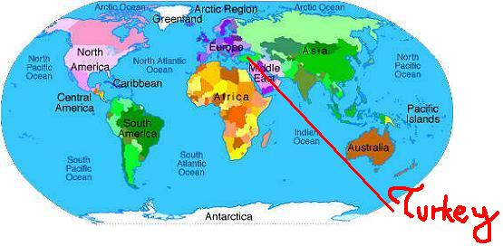

## ABOUT ANKARA

Ankara has been the capital of Turkey since October 13, 1923. The city center of Ankara is the second most crowded area of Turkey and among the first 40 of the world. Most part of Ankara’s land is located in the upper part of Sakarya. It can be considered as the heart of Turkey due to its proximity to Turkey’s geographical center and its function in Turkey’s progress. On the other hand, Ankara is one of the places in Turkey where on which several civilizations in history lived, such as the Hittites, Phrygians, Lydians, and Persians. Ankara is famous with its cat, goat, angora, rabbit, pear, honey, and grape called “Misket Üzümü”.

### Important Things about Ankara:

Region: Central Anatolia, Upper Sakarya

Official Units: 18 districts within city limits and 25 total in the province

Total Area: 2.516 km2

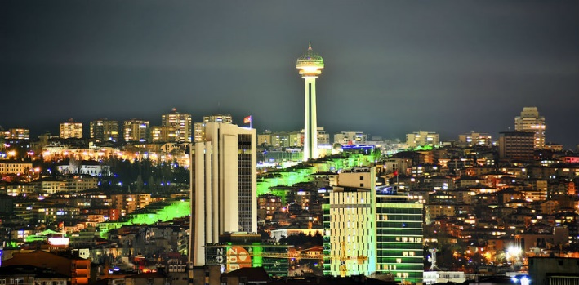Elevation: 938m

Population: 5,150,072 (2014 census)

Time Zone: EET ( UTC+2)

Postal Code: 06xxx

Area Code(s): 312

License Plate: 06

#### Weather Conditions:

Ankara has a continental climate with cold snowy winters due to its altitude and inland location, and hot, dry summers. Spring and autumn are generally mild, but during both seasons sudden hot and cold spells frequently occur in the region. Rainfall occurs mostly during the spring and autumn. Because of Ankara’s high altitude and its dry summers, night temperatures in summer months are not so high. Ankara’s annual average precipitation is fairly low at 415 mm (16 in), nevertheless rains fall during the whole year. The monthly mean temperature ranges from -0.3 °C in January to 23.6 °C in July, with an annual mean of 11.7 °C. Average highest temperature is measured generally in July and August with 30.3 °C and the average lowest temperature is measured generally in January and February with -3 °C.

## ABOUT METU

Middle East Technical University (METU) was founded under the name of "Orta Doğu İleri Teknoloji Enstitüsü" (Middle East High Technology Institute) on November 15th, 1956 to contribute to the development of Turkey and Middle East countries and especially to train people so as to create a skilled workforce in the fields of natural and social sciences. METU’s presence brought about new methods and introduced innovations to the Turkish higher education system manifesting METU as a pioneer of modern education nationwide.

In 1956, the first academic program to start education was the Department of Architecture. Then in the spring semester of 1957, the Department of Mechanical Engineering launched its academic program. At the onset of 1957-1958 Academic Year, the Faculty of Architecture, Faculty of Engineering and Faculty of Administrative Sciences were established. In 1959, the tasks undertaken to establish the Faculty of Arts and Sciences were completed. The Faculty of Education launched its academic program in 1982. Today, there are a total of 43 undergraduate programs in the five faculties of METU.

There are about 176 graduate programs available in the Graduate Schools of Natural Sciences, Social Sciences, Informatics, Applied Mathematics and Marine Sciences. Marine Sciences conducts the academic program studies at Mersin-Erdemli.

Owing to the quality academic education that emphasizes merit and excellence in scientific, cultural and intellectual studies as well as owing to the accomplished and qualified METU graduates, the University has become one of the distinguished and respectable institutions of Turkey. Today, the University is proud to employ about 770 faculty (professors, associates professors etc.), 400 academic instructors and 1,400 research assistants. It is a great pleasure to offer education to over 28,000 students. The total number of the alumni now is over 120,000.

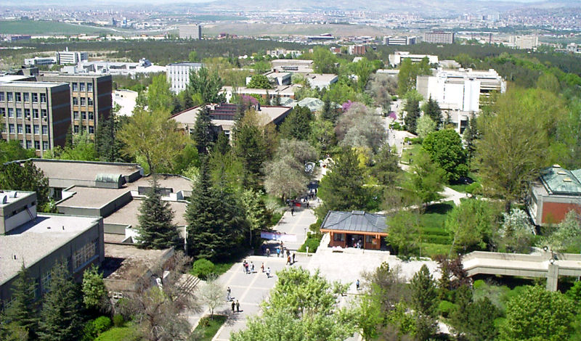

## TRANSPORTATION

**How to come to METU (ODTU)**

Ankara International Airport (Esenboğa) is about 35 km away from METU campus. Getting to campus is easy but takes some time. Depending on your flight, you may have to go through PASSPORT CONTROL and CUSTOMS INSPECTION in Istanbul or Ankara. Bear in mind that personnel may not be able to speak English well but you can still be helpful as they are accustomed to people who do not speak Turkish. If you go through customs in Istanbul, you will need to transfer from International Flights Terminal to Domestic Flights Terminal. Responsible personnel will direct you to the domestic flights terminal; check the direction signs as well.

You may need to exchange some of your foreign currency for Turkish Lira as soon as you arrive in Turkey. Bank windows are available in both airports immediately before or after passport control. Exchanging money also can be done at the PTT, open 24 hours, at both airports.

From Ankara airport to city center, you may want to take a taxi or use shuttle buses (called HAVAS or BELKO) or public buses called EGO with route number 442. If you wish to take a taxi, metered taxis are also available from the airport to the city. Taxi fares to central locations within city are approximately US$ 50-70 depending on your arrival time (arrivals after 11:30 p.m. means you pay night fare to the taxi you take, so the taxi fare increases). By law, all taxis in Turkey are metered. You pay what is on the meter; tipping is not customary. Taxi fare from HAVAS City Terminal (Ulus area) or from ASTI (Intercity Bus Station) to METU (ODTU in Turkish) campus or to most hotels will be US$ 10-15. As drivers usually do not speak English, you should have your destination address on a paper to show the driver.

**1. From Ankara Esenboga Airport**

If you want to take shuttle buses from Airport to METU campus, we suggest you to drop in ASTI Coach Station. If you get off at ASTI Coach Station, you may want to take a taxi to METU campus. Our campus is about 5 km away from ASTI towards west-side of the city. Taxi fares from ASTI to METU campus are approximately 20-30 TL. Each time you enter METU campus, you will be asked to show your METU ID card. Since you will not have your card with you for the first time you enter the campus, please have your letter of acceptance ready to show the guards when entering the campus.

**a. HAVAS Buses (Private Company)**

**Bus Schedules:** Services between airport and the city terminal will be scheduled according to the arrival times of domestic and international flights.

**Route:** Ankara Esenboğa Airport, Çubuk, Pursaklar, Hasköy, Keçiören, Etlik, Havaş City Terminal, ASTI (Ankara Intercity Bus Terminal-Coach Station)

Note: Even if there is one passenger going to the coach station, the coaches set off to ASTI just afterwards the other passengers are dropped in HAVAS City Terminal.

**Passenger Dropping Spots:** HAVAS shuttles drop passengers at Çubuk intersection, Pursaklar, Hasköy, Aydınlıkevler, Keçiören Bridge and Etlik Intersection on the way to city center.

**Arrival time:** Approximately 30 minutes to HAVAS City Terminal and 45 minutes to ASTI Coach Station

**Ticket fee:** 10TL (VAT incl.)

**b. BelkoAir Buses**

**Bus Schedules:** The buses offer services every 30 minutes from 05:00 a.m to 00:00; and every 60 minutes from 00:00 to 05.00 a.m.

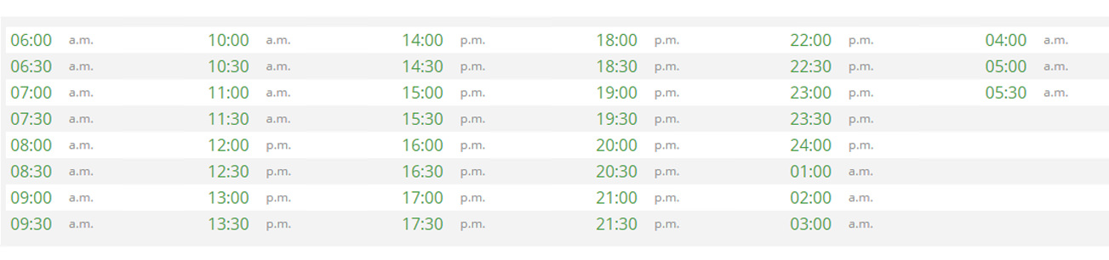

**Route:** Ankara Esenboğa Airport, Ülker, Saray, Pursaklar, Hasköy, Aydınlıkevler, Fatih Bridge, Ankamall, Gazi Hospital, ASTI (Ankara Intercity Bus Terminal-Coach Station), Kızılay, Opera, Train Station

**Passenger Dropping Spots:** There are no passenger loading stops on the route from airport to the city center. The first dropping spot is ASTI.

**Arrival time:** Approximately 60 minutes to ASTI Coach Station.(It may change depending the traffic and weather conditions)

**Ticket fee:** 10TL (VAT incl.)

**c. Public Shuttle Buses**

**Public Transport Bus Line: 442**

**Domestic Terminal:** Arrivals floor, In front of passenger exit door.

**International Terminal:** Arrivals floor, in front of passenger exit door.

**Bus Schedules**

|  |  |  |
| --- | --- | --- |
| **Weekdays, Saturdays, & Sundays** | | |
| 00:00 -  01:00 -  02:00 -  03:00 -  04:00 -  05:00 -  06:00 -  06:30 -  07:00 -  07:30 -  08:00 -  08:30 -  09:00 -  09:30 - | 10:00 -  10:30 -  11:00 -  11:30 -  12:00 -  12:30 -  13:00 -  13:30 -  14:00 -  14:30 -  15:00 -  15:30 -  16:00 -  16:30 - | 17:00 -  17:30 -  18:00 -  18:30 -  19:00 -  19:30 -  20:00 -  20:30 -  21:00 -  21:30 -  22:00 -  22:30 -  23:00 -  23:30 - |

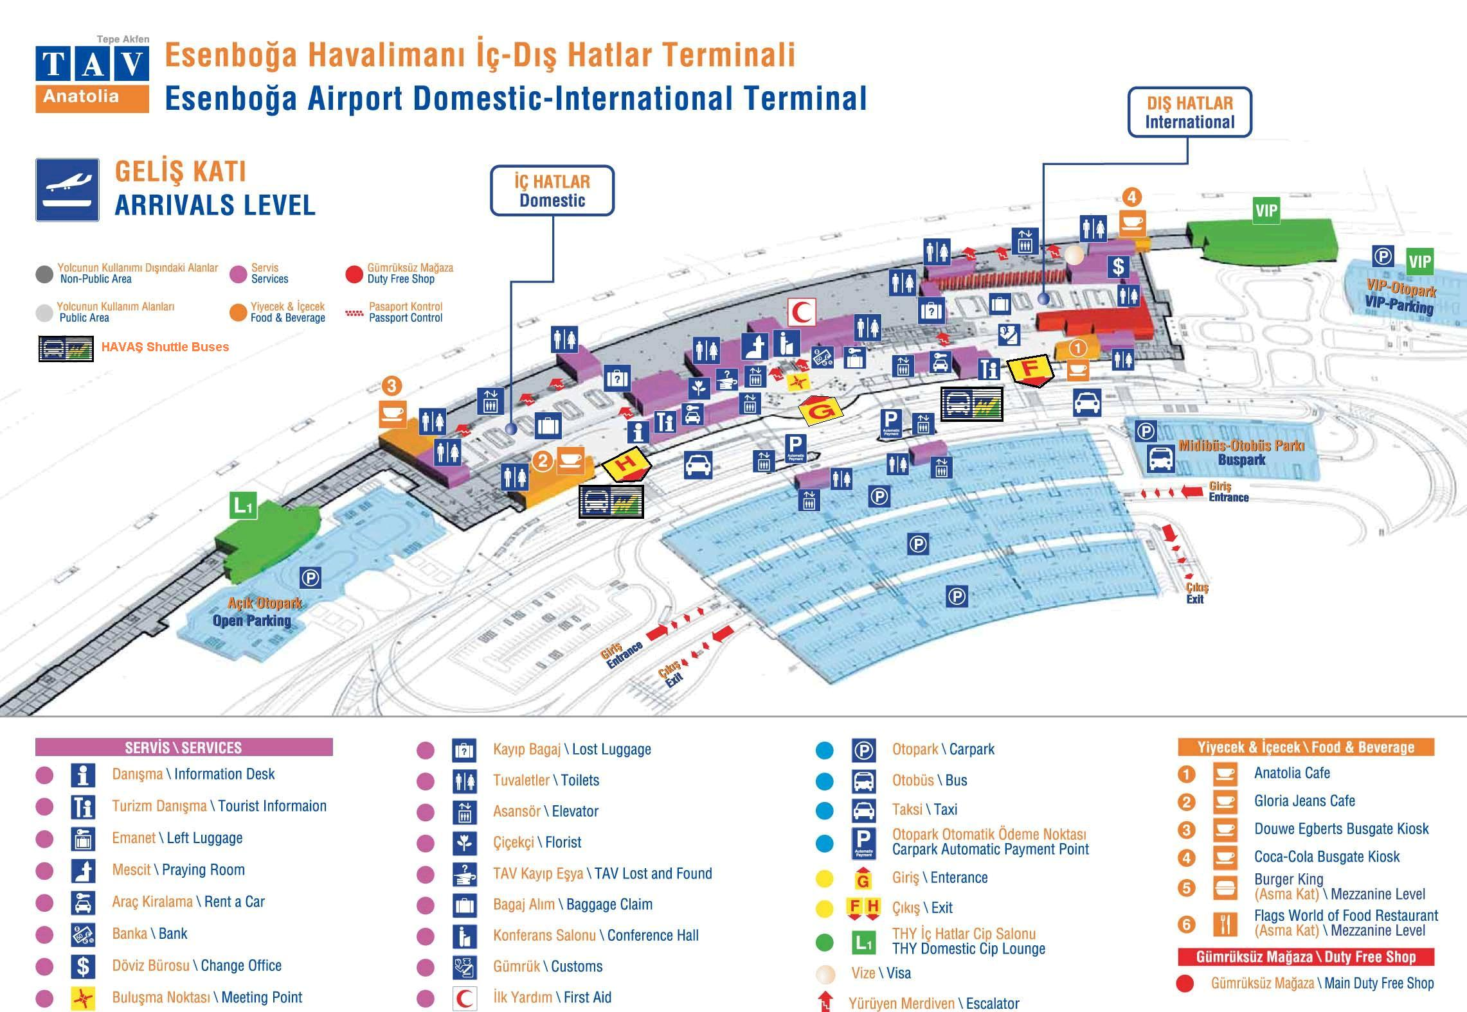

For more readable version of the map, please check: **http://www.esenbogaairport.com/tr-TR/ucus_oncesi/Documents/gelis.pdf.** Shuttle buses are located on the right hand-side of gate F for international arrivals terminal and again right hand-side of gate H for domestic arrivals terminal.

**2. Getting to Campus from the City Center**

METU is located about 7 kilometers from the center of the city at Kizilay. Transportation to and from METU campus is frequent and convenient. City buses (EGO buses), HALK buses and private minibuses (Dolmuş) have regular services from Kizilay (Güvenpark), Ulus (opposite the Radisson SAS Hotel and across from Gençlik Park) and Ayrancı (Portakalçiçeği Sokak) to the METU campus.

Bus cards are required for EGO city buses and must be purchased before boarding the bus. City bus cards are in unit format. You can buy one, ten or twenty unit cards. Each unit is around US $1.5. There are EGO booths at Kızılay and Ulus near the bus stops and on the main boulevard (Atatürk Boulevard) and at the Magazine Shop around dormitories area where you can purchase bus cards. You have to buy a ticket on the buses for HALK and double-decker buses and pay the driver on the Dolmuş.

**3. Getting to Campus from the Train Station**

Ankara train station is located around Ulus area and about 10 kilometers away from the campus. The most convenient way to come to METU is to take a taxi from the train station. Taxi fare from the station is approximately US$ 15.

**4. Campus Transportation**

The main entrance to the ODTÜ Campus, 7 km. to the city center, is Gate A1 on the Eskişehir highway. In addition to A1, the gates A4, at the “100. Yıl” District end of campus, and A7, on the Bilkent road, can be used to enter and exit Campus. Access to the city is possible via the Ayrancı-ODTÜ, Ulus-ODTÜ and Kızılay-ODTÜ shuttle routes. There is also a shuttle bus between campus stops and A2 entrance where there is a metro stop. The shuttles stop in front of the Cafeteria until 18:00 hrs. on week days; after 18:00 hrs. and on weekends they stop in the East Dormitories zone.

Ankara Municipality’s bus services (EGO) and subway (Metro) system can be used for intra-city transportation. Detailed information about the routes and hours of EGO buses is available at the URLs <http://www.ego.gov.tr/EN/indexEN.asp> and <http://www.tim.metu.edu.tr/ego-hat-bilgisi>. EGO no. 133 bus can be used for transportation between ODTÜ metro station and campus center.

It is possible to call a taxi from the dormitories at +90 (312) 219 5151 or +90 (534) 854 8684. Campus-City ring bus services are scheduled to run at certain times of the day and frequent in-Campus ring bus services (approx. every 15 min.) are available for students and staff. There are also offices of certain intercity bus companies in the East Dormitories zone.

**Campus Ring Bus Services**

Departure times of the ring bus services are listed at the URL <http://tim.metu.edu.tr/Ringler> and rings that are on service at the time of the query may be viewed at [www.ring.metu.edu.tr](http://www.ring.metu.edu.tr)

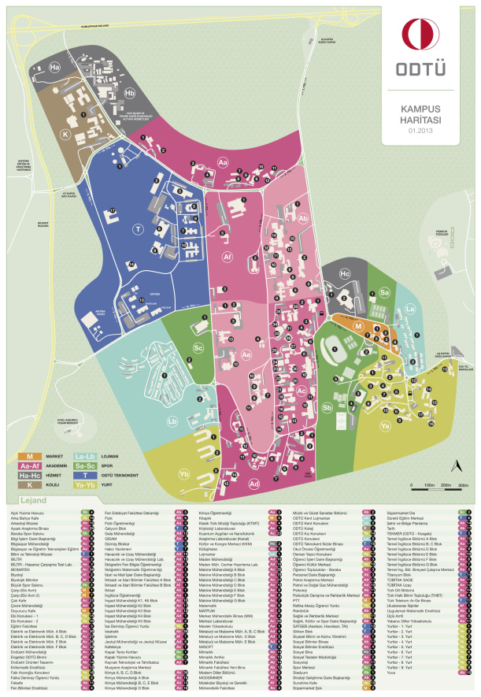

METU Guest House

Aysel Sabuncu

For more readable version of the map, please check: [**https://www.metu.edu.tr/system/files/odtu-kampus-haritasi.pdf**](https://www.metu.edu.tr/system/files/odtu-kampus-haritasi.pdf)**. For an interactive METU Map, please check:** [**http://map.metu.edu.tr/**](http://map.metu.edu.tr/)

## ACCOMODATION

**1. METU Guesthouse (ODTÜ Misafirhanesi)**

METU's Guesthouse, located on METU Campus grounds within the Campus Faculty Housing Complex, conveniently near the Sports and Social Facilities, the Shopping Mall, Banks, Post Office and public transportation facilities, provides 24-hour service to the local and international guests. METU Guest House is within walking distance from the Conference Venue. The main Guesthouse building has six two-room suites, six double rooms and six single rooms. And in separate buildings there are three large apartments together with seven studio apartments providing in all a total capacity of 52 beds for 65 guests. On the main floor of the main Guesthouse, there is a sitting room and a breakfast room open for all guests. Each room has Wi-Fi and cable internet, a cable TV, a telephone, and a small refrigerator. A computer with Internet connection, located in the sitting room on the ground floor, is available for all guests. Hot water is available for 24-hours. Daily served open-buffet breakfast is also available for the guests.

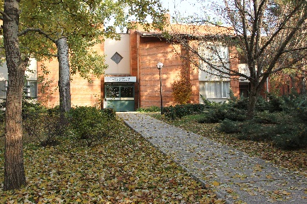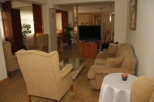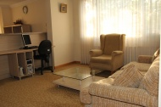

**2. Aysel Sabuncu Yaşam Merkezi (Aysel Sabuncu Life Center)**

Located inside the campus of Middle East Technical University, Aysel Sabuncu has a capacity of 66 beds: 6 single suites, 6 two-person suites and 24 double rooms. There are refrigerators, telephones, central music system, Wi-Fi and cable internet, cable TVs and 24 hour hot water in all rooms. Aysel Sabuncu is located inside METU Tecnopolis (ODTU Teknokent).

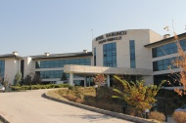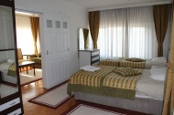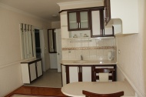

**Note:** The information presented above has been extracted from the website: [http://www.stm.metu.edu.tr/#AYSELSAB](http://www.stm.metu.edu.tr/). The brochure about Ayse Sabuncu Life Center can be downloaded from <http://www.stm.metu.edu.tr/ayselsabuncu.pdf> *Source:* <http://www.ttc.metu.edu.tr/accomm.htm>

## USEFUL INFORMATION

**a. Embassies**

It is recommended that you register with your embassy in Turkey for your benefit. The contact information of the embassies in Turkey is provided below: https://diplomatic.mfa.gov.tr/missions.aspx?selMenuId=4

**b. Banks**

There are branches of seven banks, namely İş Bank, Halk Bank, Akbank, VakıfBank, Garanti Bank, Ziraat Bank and Yapı Kredi Bank, in the Campus shopping zone. There are also ATMs of these banks at various locations. In addition, there are ATMs of ING Bank and Finansbank, all of which do not have branches on Campus. The banks on Campus operate during working hours throughout the week and their phone numbers are as follows:

Bank Phone:

* İş Bank ODTÜ Branch +90 (312) 210 38 91-92/210 2774/210 11 94
* Yapı Kredi Bankası ODTÜ Branch +90 (312) 210 38 88/210 14 14
* Akbank ODTÜ Branch +90 (312) 210 10 72-73/210 38 98
* Vakıfbank ODTÜ Branch +90 (312) 210 10 57-58/210 38 99
* Ziraat Bank ODTÜ Branch +90 (312) 210 27 62/210 11 72/210 38 94
* Garanti Bank ODÜ Branch +90 (312) 210 13 69/210 18 43/210 38 93
* Halk Bank ODTÜ Branch +90 (312) 210 12 38/210 13 73/210 15 48
* Garanti Bankası ODTÜ Branch +90 (312) 210 13 69

**c. Post Office and Cargo**

The Post Office is near İş Bank on the campus. Working hours for the post office is 08:30-12.00 and 13:30-17:00. All the telephone booths on ODTÜ Campus are card phones. These cards are available at the ODTÜ Post Office. The card phones can be found at the entrance of all the buildings of the university and at the post office. Students cannot make local, intercity or international calls via the ODTÜ telephone central. When necessary, they can use the ODTÜ telephone central only for in-campus calls.

The telephone number of post office is 90 (312) 210 27 76. There is one cargo branch in ODTÜ called UPS, which is ready to give service. The address of this cargo branch is; ODTÜ Campus, EBİ Shopping Center, No: 26 and the telephone number is 90 (312) 210 13 08.

**d. Unit of Currency in Turkey**

The currency unit of Turkey is Türk Lirası (Turkish Liras, TL) and its symbol is as in the following:



1 Turkish Lira is subdivided into 100 Kuruş (kr). 1 USD is around 3 TL and 1 Euro is over 3,3 TL (these figures may fluctuate). Coins and banknotes are demonstrated as follows: Coins: 5 kr, 10 kr, 25 kr, 50 kr, 1 and Banknotes: 5, 10, 20, 50, 100, 200.

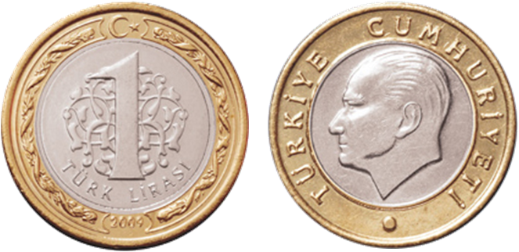

Cost of living in Turkey depends on location and life choices. You can buy the things you need cheap-moderate-expensive; like in many other destinations, it depends on your choices. The below table shows approximate sample prices from Turkey:

**Item Turkish Lira USD**

Bread 300 gr 1 TL 0.33 $

1 kg cheese 15-20 TL 6-7 $

1 lt water in grocer’s 1 TL 0.3 $

1 kg sugar 4 TL 1.3 $

1 kg flour 2 TL 0.75 $

1 kg chicken 8 TL 2.5 $

A dozen of eggs 4 TL 1.3 $

1 kg veal 35-40 TL 11-14 $

A cup of coffee in 5-8 TL 2-3 $

moderate coffee shop

Coke 330 ml (in supermarkets) 2 TL 0.7 $

Hamburger 6 TL 2 $

Bus/Subway tickets for students 1.75 TL 0.6 $

Dolmuş (minibus) 2.50 TL 0,80 $

Movie ticket for students 9-12 TL 3-5 $

Theatre ticket for students 8 TL 3 $

1 lt fuel oil 4.5 TL 1,5 $

Meal at inexpensive restaurant 15 TL 5 $

## SOCIAL LIFE

**a. Where to Eat?**

**1. Eateries Places on Campus**

The Main Student Cafeteria offers a fixed menu at noon and evening to all students at nominal cost. Additionally, students can choose from a variety of eating places, all inexpensive, in most buildings on Campus. Canteens and fast food eateries in these buildings are open from 8:00 until 16:00. There are canteens in dormitories as well. These are open from 7:30 to 23:30. The Shopping Mall in the campus shopping district has a wide variety of eating places, open from 8:30 to 23:30, to suit everyone’s taste and pocketbook. For those who would like to spend a day at ODTÜ’s lake, Eymir Lake, there are restaurants and fast-food kiosks.

**2. Eating Places in the City**

Kızılay District

Sakarya Caddesi (Street) between Selanik Caddesi and Atatürk Blvd. is famous for its “Döner” (Meat roasted on a revolving vertical spit). This meat, or chicken, fish or meat balls if preferred, is put in a half loaf of bread with onions. There are eating places in this district with other types of food, also inexpensive and to be recommended. Yüksel Caddesi (Street) is a street with many inexpensive and good restaurants, cafeterias and pastry shops. On Kumrular Sokak (Street), behind YKM Department Store near the ODTÜ Dolmuş stop, there are small eating places including the Toprak Mahsulleri Ofisi (Soil Products Office), which has a small outdoor stall that sells a variety of foods made of lentils. On Olgunlar Sokak (Street), running from Atatürk Blvd. to Kocatepe Cami (Mosque), there are several restaurants, kebab restaurants, and sandwich and snack bars. Nearby on Konur Sokak, there are inexpensive restaurants frequented by students. Some of them are not open on Sundays.

Kavaklıdere District

Tunus Caddesi (Street) is another inexpensive, convenient district for eating. Near the ODTÜ Bus Stop on Tunus Caddesi there are small kebab restaurants, cafes and sandwich shops. Prices here are moderate to moderately expensive.

Bahçelievler District

7. Cadde (7th Street) is the major shopping street in Bahçelievler and has a wide variety of inexpensive to moderate restaurants and sidewalk cafes and pastry shops. One should also look on the side streets of 7. Cadde, especially for small home style restaurants that serve inexpensive and tasty Turkish dishes.

**b. Where to Shop?**

**1. Shopping Centers on Campus**

Students will find convenient shopping facilities and personal services on campus. The Shopping Mall across from the Tennis Courts has a number of shops, including a variety of clothing shops, stationary shops, bookstores and pharmacy as well as a variety of fast food eateries. Next to this mall is a Super Market where students can buy a variety of personal needs and a small selection of groceries. In this general business area, there are hairdressers for men and women, a tailor and a shoe repairman.

The Campus Bookstore adjacent to the Super Market, and a small branch in front of the Main Student Cafeteria building, has textbooks for sale. Students will find Stationary Shops conveniently located on the ground floors of the Architecture Faculty building and the Economics and Administrative Sciences Faculty building.

**2. Shopping Centers in the City**

A list of shopping centers has been prepared for students new to Ankara. Many of the centers listed below are arcades (pasaj or çarşı) which are located on the ground and basement floors of buildings. These collections of shops are convenient and often inexpensive places to buy clothing, personal needs and household goods. Additionally, some of the major inexpensive and moderately priced department stores are listed.

* Tunalı Hilmi Çarşısı (Kavaklıdere): Clothing, personal and household needs Prices: Moderate to expensive
* AnkaMALL Alışveriş Merkezi (Konya highway, Akköprü district, next to Ankara Security Office): Clothing, cosmetics, grocery, electronic equipment, movie theatre, restaurants, dry cleaning. Prices: Expensive
* Armada (Eskişehir Highway, Söğütözü): Shoes, bags, underclothing, clothing, cosmetics. Prices: Expensive
* Next Level (Eskişehir Highway, Söğütözü): Shoes, bags, underclothing, clothing, cosmetics. Prices: Expensive
* Real Center (Bilkent): Home equipment, clothing, shoes, restaurants, movie theatres, dry cleaning, grocery. Prices: Expensive
* CEPA Alışveriş Merkezi (Eskişehir Highway): Clothing, cosmetics, grocery, electronic equipment, movie theatre, restaurants, dry cleaning. Prices: Expensive
* Kentpark Alışveriş Merkezi (Eskişehir Highway): Clothing, cosmetics, grocery, electronic equipment, movie theatre, restaurants, dry cleaning. Prices: Expensive
* Panora Alışveriş Merkezi (Oran): Clothing, cosmetics, grocery, electronic equipment, movie theatre, restaurants, dry cleaning. Prices: Expensive
* Taurus Alışveriş Merkezi (Konya Highway): Clothing, cosmetics, grocery, electronic equipment, movie theatre, restaurants, dry cleaning. Prices: Expensive

**3. Bookstore (Kitabevi)**

A limited number of English textbooks and dictionaries can be purchased in bookstores such as:

Kızılay District

* Dost Kitabevi – Music Center (Konur sokak No: 8, Bilkent Shopping Center)
* D&R (Ankamall Shopping Center, CEPA Shopping Center)

Second-hand book shops are generally clustered together in some arcades (pasaj) or streets. Kitapçılar Park (Book Shop Park) located on Olgunlar Sokak at Bakanlıklar has a number of small shops on the Pedestrian walkway which sell a variety of textbooks and other books in English. Other clusters of shops can be found in Karanfil Pasajı and Birlik Pasajı, both on Karanfil sokak at Kızılay.

**c. Where to Go?**

In Ankara there are many attractive museums, mosques, archaic towns, temples, etc. Some attractive places to visit are listed below:

* Ankara Castle (Citadel): Ankara castle whose exact construction date is unknown is as old as the city itself. It is a must see in Ankara since it is so alive in spite of its old history. There are a lot of amazing antique and souvenir shops and a museum.
* Anıtkabir: It is the mausoleum of the leader of the Turkish War of Independence and the founder of the Republic of Turkey, Mustafa Kemal Atatürk. Anıtkabir features Turkish as well as Seljuk and Ottoman architectural and ornamental features. There are many statues, towers and a museum.
* Hamamönü - Altındağ: Hamamönü, which is a place reflecting traditions of the Ottoman Empire and Republic of Turkey, is a unique place worth to see. There are mosques, Turkish baths, museums, and parks.
* Beypazarı: Beypazarı is a town located about 100 km west of Ankara. In the Ottoman period, Beypazarı was a military base and was important for the local economy. Its carrots and mineral water are very famous. There are some museums, old buildings and many places to walk and picnic.

**1. Cinemas**

Following are the names and locations of cinemas popular among students. These cinemas are in the original language with Turkish subtitles:

* AFM ANKAmall IMAX, ANKAmall Shopping Center No: 2/242
* Bahçelievler Büyülü Fener, 7. Cadde 18. Sokak
* Kızılay Büyülü Fener, Hatay Konak No:18
* Prestige Bilkent, Bilkent Shopping Center No: 5
* AFM CEPA, CEPA Shopping Center, Eskişehir Yolu
* Kentpark Prestige, Kentpark Shopping Center, Eskişehir Yolu
* Cinemaxiumum, Next Level Shopping Center, Eskisehir Yolu
* Cinebonus Panora, Panora Shopping Center, Oran
* Armada Movie Theatres, Eskişehir Yolu No : 6/B Blok No: 188

**2. Music**

* Presidential Symphony Orchestra Hall: Talatpaşa Blvd 38/A Sıhhiye
* State Opera and Ballet: Atatürk Blvd, Opera Meydanı, Ulus
* Bilkent Symphony Hall: Bilkent University (Buses leave from the bus stop at Tunus cad. and pass by the National Library Bus Stop at Bahçelievler 30 minutes before the concerts and return to these places after the concerts.)

**3. Museums**

* Museum of Anatolian Civilization**:** Ankara’s most famous museum is located at Hisarpark Cad. Ulus. It is open daily from 8:30 to 17:30
* Atatürk’s Mausoleum (Anıttepe Cad. Tandoğan): Open daily from 9:00 to 17:00, the grounds are a pleasant place for walking and sitting
* METU Archeology Museum: Located near the Faculty of Architecture, the museum is open weekdays from 08.30 until 17.30 and exhibits items discovered from METU’s own territories.

**4. Art Galleries**

Ankara has a number of Art Galleries featuring modern Turkish artists. These galleries are listed in publications of the Ministry of Tourism.

* Cer Modern: It is a center in which you can find one of the most precious presentations of modern art with several exhibitions and activities in Ankara. Its address is Altınsoy Street, No: 3 Sıhhıye.
* ATO: ATO Congresium & Exhibiton Center is one of the crucial basic stones of Ankara as an opening gate to the world with its exhibitions and activities and worth to see. Its address is Söğütözü Street, No: 1/A Çankaya
* Kültür ve Kongre Merkezi (KKM): The Cultural and Convention Center of METU, which encompasses the most recent technological facilities, is designed to host local and international conventions, seminars, meetings, conferences, concerts, other cultural activities and related services. The center consists of nine halls, two foyers, a restaurant, support and service units and benefits from the rich facilities and resources of METU campus.

**5. Places to Hang Out**

Yüksel Caddesi at Kızılay

It is a street with many cafeterias where students can play chess, checkers, backgammon and billiards. On this street, there are inexpensive and good restaurants as well as a number of bookstores.

Tunalı Hilmi Caddesi at Kavaklıdere

A street filled with shops and small eating places. At the end is Kuğulu Park, a nice place to sit. BELPA Ice Skating Palace at Bahçelievler (Across from the National Library). It is a recreation center with an ice rink, chess, table tennis, gym facilities, a cafeteria and restaurant, and an art gallery.

7. Cadde at Bahçelievler

It is a street filled with cafes, small restaurants and pastry shops and cinemas.

Sakarya Caddesi (Kızılay), Tunus Caddesi (Kavaklıdere) and Park Caddesi (Çayyolu)

A pedestrian walkway with many cafes, bars, restaurants with moderate prices

**INTERNATIONAL COOPERATIONS OFFICE**

Solmaz Izdemir Hall, Main Library Building

Middle East Technical University

Universiteler Mah. Dumlupinar Blv. No:1

06800 Ankara TURKEY

**www.ico.metu.edu.tr**

