Warm greetings from ISW Secretariat!

Dear Partners /Colleagues,
On behalf of Universiti Teknologi Malaysia (UTM), we are pleased to invite you to the International Staff Week, themed ‘Sustainable Partnerships for Universal Prosperity’, that will be held from October 28th to November 3rd 2019, at our campus in Johor Bahru, Johor, Malaysia.
Targeted participants would be administrators who are in charge of mobility and international affairs from universities outside Malaysia.
The objectives of the seven-day programme are as follows:
• to enhance skills and competencies in managing international office;
• to nurture intercultural competencies and international understanding; and
• to share best practices in various areas related to international relations and activities.
The programme features a Mini Seminar ‘Internationalisation for Sustainability’ where participants can submit and present their abstract on topics related to the theme. There will also be a Meet & Greet session in Townhall style where participants can share information about their university to UTM staff and students.
In addition, they will also be participating in various campus activities including UTM campus and Johor Bahru city tour, our 63rd Convocation Ceremony, convocation festival and convocation dinner.

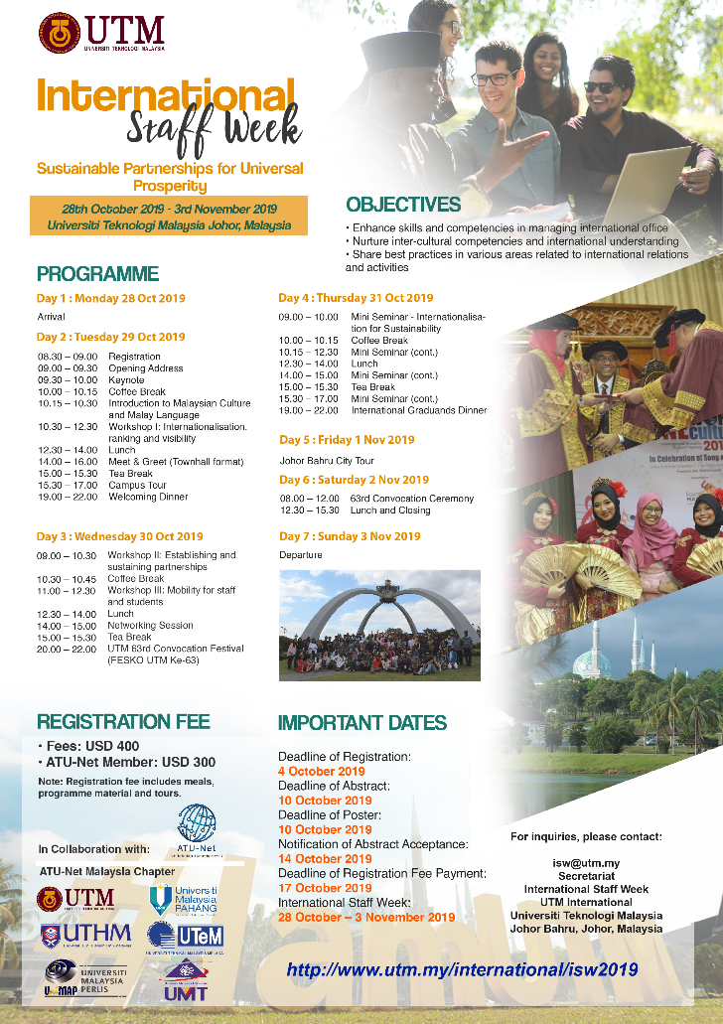
Registration will be closed by 4 October 2019. If you are interested to join please register via this link, https://forms.gle/iJ2GQFLhjJyqvqH29. Seats are limited and by first come first serve basis only. For any other inquiries, please do not hesitate to contact us at isw@utm.my.
We would appreciate it if you could pass this information to the respective administrators who are in charge of mobility and international affairs of your university. The latest updates and further information can be found at http://www.utm.my/international/isw2019.
*Please disregard the content of this email if it does not apply to you*

Secretariat
International Staff Week 2019
UTM International
Universiti Teknologi Malaysia (UTM), 81310 Johor Bahru, Malaysia
Tel: +607 5536846
Secondary Email: relations@utm.my

Site: www.utm.my/international/isw2019/

