Dear Esteemed Colleagues,

This is to kindly remind you that there is one week remaining to apply for the 2nd edition of the Erasmus+ International Staff Week.

To secure your place, please submit your application by May 1st. For a comprehensive overview of the event's agenda, kindly refer to the attachment included in the previous email.

We thank all who have already registered for the event or acknowledged the receipt of the invitation letter.
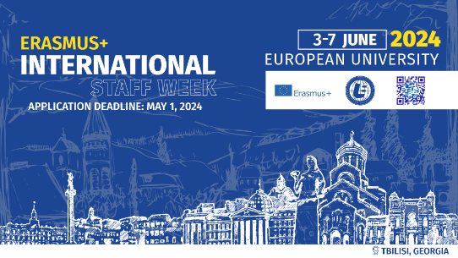
Kind Regards,
International Relations Office
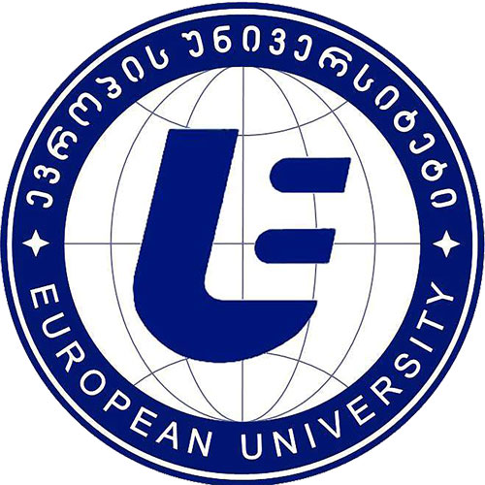
Tel: +995 32 2 000171 (147)
Add: Guramishvili Ave. 76, 0141, Tbilisi, Georgia
Web: www.eu.edu.ge

On Thu, Apr 18, 2024 at 11:14 AM Staff Week <staffweek@eu.edu.ge> wrote:
Dear Esteemed Colleagues,

Warm greetings from European University, Tbilisi, Georgia.

European University Erasmus Office is thrilled to extend a collegial invitation to the summer edition of the Erasmus+ International Staff Week. This distinguished event is scheduled to unfold from June 3rd to 7th, 2024, encompassing three days in Tbilisi and two days in Kutaisi, acknowledging our partnership with Kutaisi University, which shares ownership with European University.

Who Should Attend:
We cordially invite International Office representatives, Erasmus managers, and vice rectors or vice deans overseeing internationalization at their respective institutions to join us for this enriching experience. Whether you are an existing partner dedicated to strengthening collaborations or a university aspiring to forge new ties, your presence will be invaluable.

Event Overview:
The program offers a dynamic blend of academic insights and cultural exploration. Participants will engage with the academic life of both European University and Kutaisi University through faculty presentations and campus tours. Additionally, they will immerse themselves in Georgian history and language via designated workshops and explore the rich cultural heritage of Tbilisi and Kutaisi through guided sightseeing tours.

For a glimpse of the inaugural event and its content, please see a recap video for your reference (Georgian parts are subtitled in English, and vice versa).

Funding and Expenses:
Participation is free of charge. European University is committed to covering all costs directly linked to the events outlined in the agenda, including meals, transportation to and from Kutaisi, workshops, and organized touristic activities. However, participants are kindly requested to bear their own travel expenses, such as airfare and accommodation both in Tbilisi and Kutaisi. We encourage the utilization of Erasmus funds or other available resources to facilitate your participation.

Registration:
To secure your place, please submit your application by May 1st. For a comprehensive overview of the event's agenda, kindly refer to the attachment included with this email.

We eagerly anticipate your participation in what promises to be a collaborative gathering, shaping the future of our partnership and establishing or fortifying the bonds between our esteemed institutions.
Kind Regards,
International Relations Office

